**Team:** Amanda Blair, Cole DeVoy, Zach White

**Date:** May 7, 2020

**U.S. Attitudes Towards China During the Coronavirus Pandemic**

1. **Introduction**

On 31 December 2019, the government of the People’s Republic of China reported multiple cases of pneumonia, then of unknown origin, to the World Health Organization (W.H.O.).[1] Concentrated in Wuhan, the causal agent for this pneumonia was isolated and identified as a new, particularly contagious member of the coronavirus family; the disease it caused was formally named “COVID-19” on 11 February 2020.[2] The W.H.O. and the U.S. government both initially praised the Chinese government’s response to the outbreak, with W.H.O. director-general Tedros Ghebreyesus[3] and U.S. president Donald Trump[4] praising Chinese authorities for their transparency and effectiveness.

However, the COVID-19 virus eventually spread beyond China’s borders and to the United States. By 16 March 2020, the states of California, New York, and Illinois had issued statewide “stay-at-home” orders[5] while the White House had approved a set of temporary social distancing measures aimed at combating the spread of the disease.[6] Universities, public spaces, and private businesses entered a period of restriction unprecedented in recent U.S. history, with public health and economic concerns eventually coming to dominate conversations throughout the country.[7] By 30 April 2020, the United States had confirmed over a million COVID-19 cases within its borders and upwards of 60 thousand deaths - with no end in sight.[8] The ongoing COVID-19 outbreak has already established itself as an event of historical significance within the U.S. public consciousness, yet its political implications extend beyond the realm of the purely domestic and into the geostrategic.

The COVID-19 virus arrived during a major shift in the relationship between the United States and China. After forty years of peaceful diplomatic and economic relations, new tensions have arisen between the two powers, with some analysts predicting that “China’s rise” will at some point draw the pair into military conflict.[9] Different presidential administrations have responded to these newfound strains in profoundly different manners. President Obama’s 2015 National Security Strategy, for example, recognized the potential for U.S. competition with an increasingly powerful China but nonetheless emphasized the possibility for their cooperation and mutual benefit.[10] A mere two years later, President Trump’s National Security 2017 struck a markedly variant tone, declaring that “China and Russia challenge American power, influence, and interests, attempting to erode American security and prosperity.”[11]

The COVID-19 virus’ origins in China have imbued it with a degree of political relevance and sensitivity in the United States that would likely be absent had it first appeared elsewhere in the world. Some analysts have already claimed that Democrats’ and Republicans’ differing positions on the appropriate response to the COVID-19 virus are destroying any consensus on U.S.-China policy that may have once existed.[12] What this demonstrates, at the very least, is that there is some connection being made between the COVID-19 virus and China at the federal level; we seek to investigate, and if possible measure certain aspects of, that connection.

While much attention has been paid to President Trump’s unique approach to both the COVID-19 virus and U.S. relations with China, comparatively little has been directed at the wider group of federal-level elected officials in the United States. These highest-profile Democrats and Republicans - the 529 voting members of the 116th United States Congress - represent not only two at-odds political parties, but states and localities that have thus far had immensely varied experiences with the COVID-19 virus. They, and their public communications, will be our subjects.

We ask: is there a relationship between the severity of the outbreak in a Congressperson’s state and their publicly-expressed sentiment toward China? Furthermore, is there likewise a demonstrable difference in that sentiment between members of the Democratic and Republican parties? For our purposes, a “Congressperson” is any member of the United States Congress (it is not restricted, as is sometimes the case, to members of the House). “Publicly-expressed sentiment” will be measured through an analysis of a Congressperson’s Tweets, specifically those Tweets that mention China (with the limitation that those Tweets cannot have been posted prior to 1 January 2020, the day after China’s first COVID-19 report to the W.H.O.). In an increasingly polarized United States, even minor issues can come to take on inflated partisan significance. Using a variety of Python methods, we hope to shed some light on how partisanship might be affecting the way federal legislators communicate on two undeniably major ones: China and the COVID-19 pandemic.

1. **China Tweets by Political Party**

* 1. **Background**

The COVID-19 virus arrived in the United States during the 116th meeting of the United States Congress. In total, the voting members of the 116th Congress (across the Senate and House of Representatives) include 277 Democrats, 249 Republicans, and 3 independents (out of 529 voting members).[13] We decided to first investigate the raw number of Democratic and Republican lawmakers who had sent Tweets featuring language related to China over the course of the COVID-19 pandemic. Because the COVID-19 did not begin to become a fixture of the U.S. media scene until after China’s 31 December 2019 report to the W.H.O., we limited the time frame for the Tweets in which we were interested to those sent on or after 1 January 2020. We were curious: Were more Democrats Tweeting about China during this period? More Republicans? What were the numbers of lawmakers Tweeting about China as a proportion of their respective parties (that is, of the overall number of Congresspersons belonging to their party)? We determined that this would provide initial insight into the partisan lean of China-focused “Tweeters” in Congress and serve as a springboard into more sophisticated analysis later on within our study.

* 1. **Methodology**

We first found an online spreadsheet featuring a comprehensive list of the Twitter handles for each member of the 116th Congress.[14] We used Pandas to create a DataFrame out of this spreadsheet, indexed it by Twitter handle, used a for-loop to create a list of Twitter handles from the DataFrame, before finally using Tweepy API to scrape through the 100 most recent Tweets associated with each of these handles. We stored this information in a dictionary, for which the keys were the Twitter handles and the values were the recent Tweets. Then, using a series of for loops, we created a new dictionary, with each Congressperson’s Twitter handle remaining a key but with the values now exclusively recent Tweets featuring keywords like “China”, “Chinese”, or “Beijing”. During this process, we also limited the Tweets to those that had been sent on or after 1 January 2020. We converted this dictionary into a DataFrame, merged that DataFrame with our initial DataFrame, performed a sentiment analysis using TextBlob (discussed below), and used a for-loop to drop the columns associated with those handles for which no “China Tweets” were recovered. Having “cleaned” our data in this manner, we dove into our initial analysis. We hypothesized that because Democrats outnumber Republicans in the U.S. Congress, we would recover China Tweets from more individual Democratic Congresspersons than individual Republican Congresspersons.

* 1. **Analysis**

As reflected in Figure 1, our hypothesis was disproved straight away. Despite the larger number of Democrats in the U.S. Congress, our China-related keywords appeared in Tweets made by 133 individual Republican Congresspersons and only 38 individual Democratic Congresspersons. That is to say some 53% of the total number of Republicans in Congress had mentioned China or its government in a recent Tweet, compared to just under 14% of Democrats.

**Figure 1. Number of Congressional “Tweeters” on China by Party**

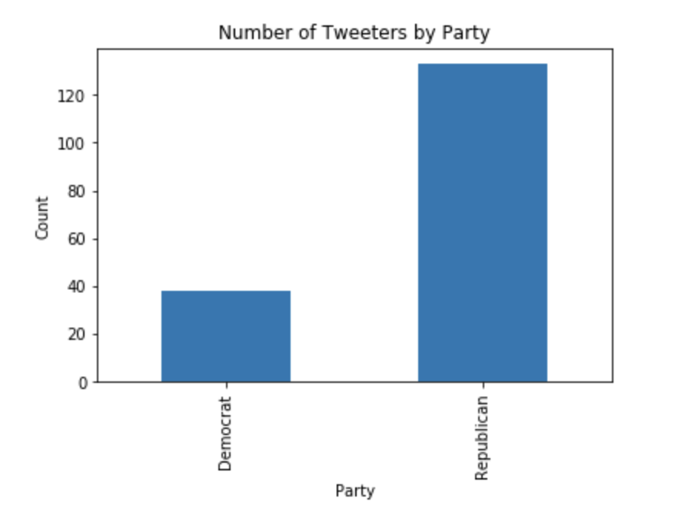

In both absolute and relative terms, Republicans *have* displayed a greater tendency to mention China in their most recent Tweets vis-a-vis Democrats. This could reflect a growing partisan divide among federal lawmakers on the U.S. approach to China. Such a split would mirror the same difference in overall tone toward China between the Democratic Obama administration and the Republican Trump administration, as seen in their contending National Security Strategies. It would also confirm the aforementioned reporting that the COVID-19 pandemic has begun to “unravel” any pre-existing consensus on the U.S. China policy that might have once existed between Democratic and Republican officials.[15] Moreover, it could portend the onset of a Republican strategy to drum up anti-China sentiment in an effort to boost President Trump’s re-election efforts (discussed in Section IV).

* 1. **Limitations and Areas of Further Research**

Because of time-frame and quantity limitations inherent to the Tweepy API tool, a majority of the Tweets we recovered were posted during the month of April 2020. While this means we were able to analyze Congresspersons’ most recent communications, it does limit our ability to gauge the full extent of “China Tweeting” by the beginning of global COVID-19 concerns around 1 January 2020. While our list of keywords focused on what we determined to be the most relevant phrases for our study (“China”, “Chinese”, etc.), it was by no means exhaustive. Tweets mentioning China obliquely, as a part of a larger chain, or in unexpected language would not have been captured by our scraping code. While we were able to recover a great many China Tweets using our methods, we make no claim to universality. Further research is necessary to explore and track the likely expansive array of means by which elected officials in the United States communicate with their constituents about China, and the language they use when they do so.

1. **Polarity of China Tweets**
   1. **Background**

Having concluded that more Republican Congresspeople have Tweeted about China since the beginning of 2020 than their Democratic counterparts, we set out to explore the sentiment of these Tweets. Namely, we hoped to discover whether the polarity of the Tweets, as evaluated by TextBlob, was independent of the political party of each Congressperson and of the number of confirmed cases of COVID-19 in the Congresspeople’s respective states. Based on recent reports of a shift in Republican strategy in targeting China’s handling of the Coronavirus outbreak, we hypothesized that the mean polarity of China-related Tweets from Republican lawmakers would differ from that of Democrats. Further, we hypothesized that an increased number of confirmed cases would lead to a more negative tone in Tweets.

* 1. **Methodology**

Beginning with our DataFrame from the previous section, we used TextBlob to perform sentiment analysis on each lawmaker’s Tweets. The Tweets were concatenated together, so our analysis was performed on the entire text of each lawmaker’s China-related Tweets, rather than on each Tweet separately. This sentiment analysis provided us with a polarity value (from -1.0, for very negative, to 1.0 for very positive) and a subjectivity value (ranging from the very objective 0.0 to very subjective 1.0) for each lawmaker’s Tweets. We used this to analyze the mean polarity of Tweets for each state regardless of party identification. Next, we separated Congresspeople by party and then analyzed differences between states within each party. Finally, we ran a two-tailed t-test to see whether the mean polarity value of Tweets from Republican members of Congress is equal to that of Democratic Congresspeople’s Tweets. Next, in order to analyze the relationship between the severity of the COVID-19 outbreak in each state and how those states’ lawmakers talk about China, we ran an ordinary least squares regression using the number of confirmed cases per state as the explanatory variable and the polarity of Tweets from each state’s members of Congress as the response variable.

* 1. **Analysis**

As an initial step, we created a bar chart showing the mean polarity of China-related Tweets by lawmakers from each state. As can be seen in Figure 2, the polarity varied widely, ranging from extremely positive (as in the state of Kansas) to slightly negative in a number of cases.

**Figure 2. Polarity of China Tweets by State**

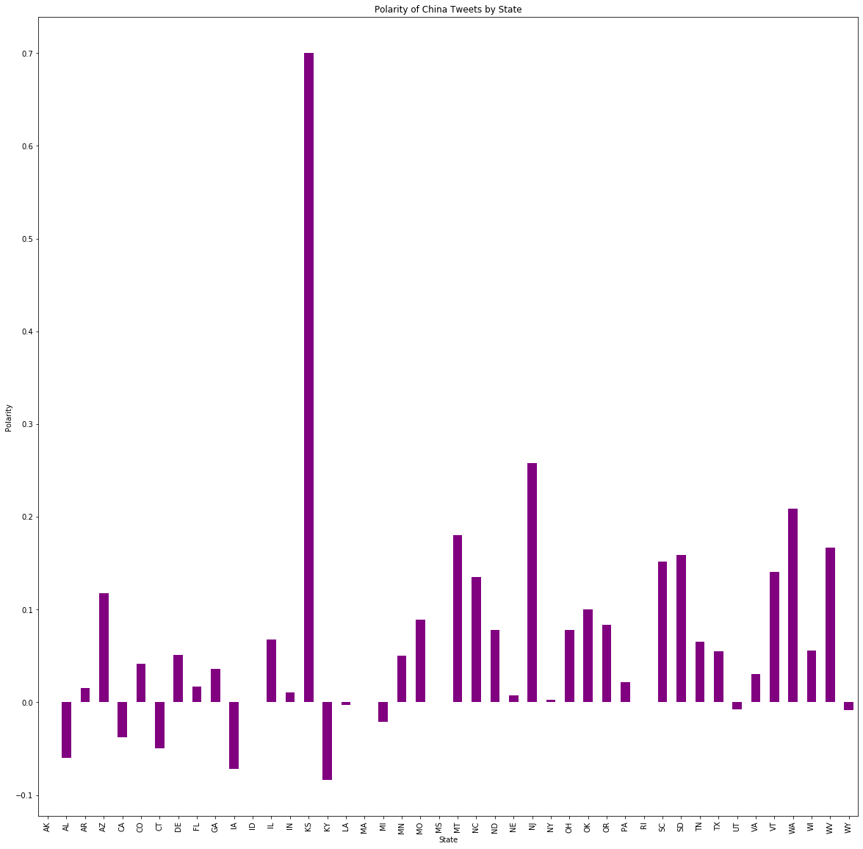

As this chart showed such wide variation, we decided to break it down further, with Tweets separated first by party and then by state, as shown in Figure 3 below.

**Figure 3. Polarity of China Tweets by State for Democrats (Left) and**

**Republicans (Right)**

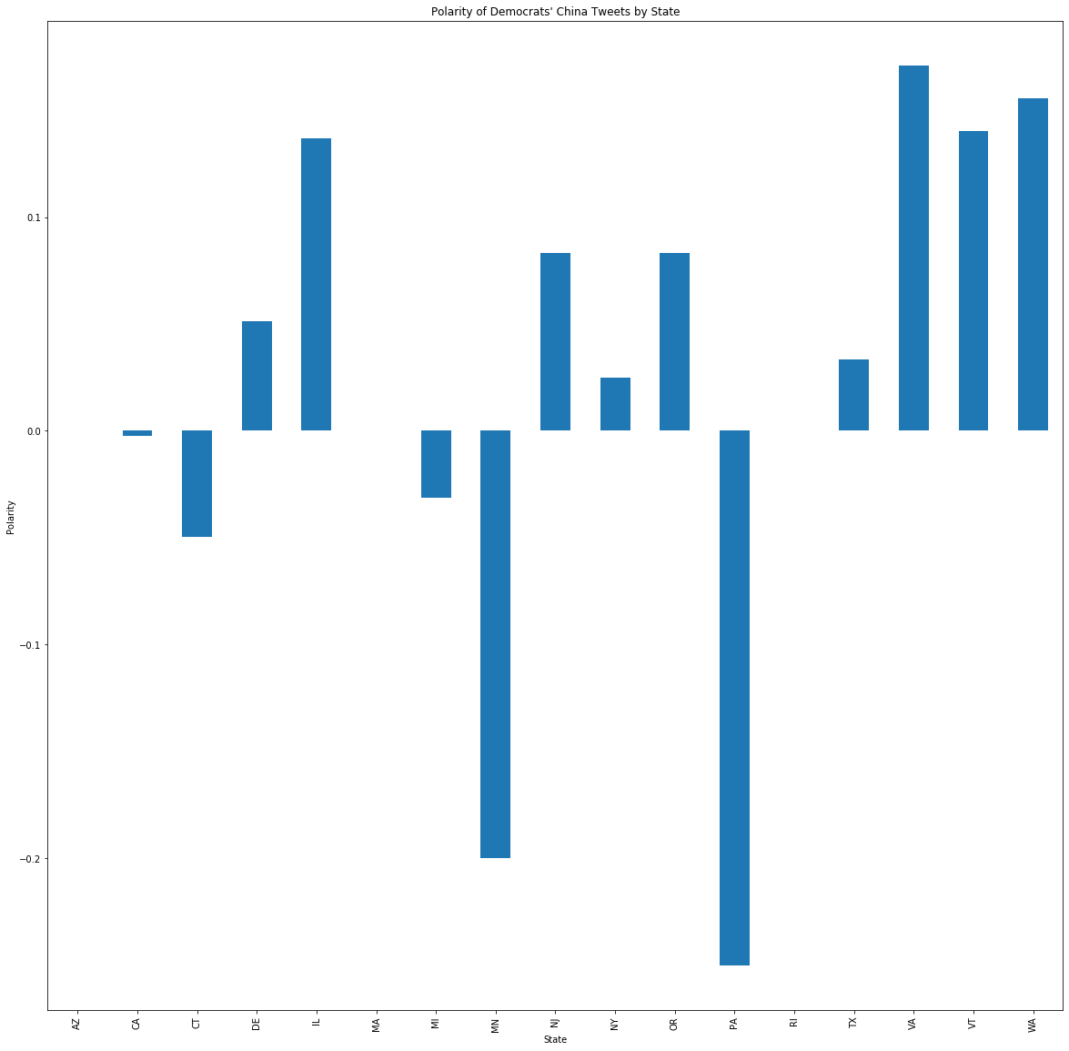 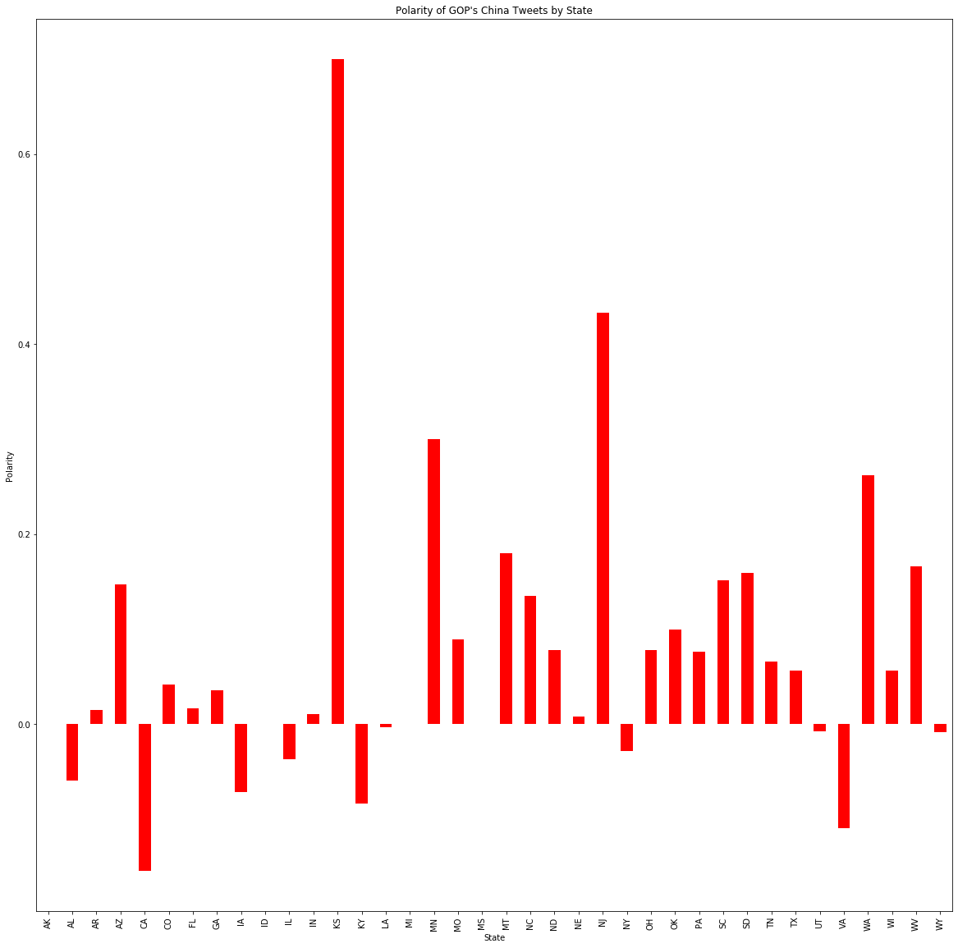

Even when divided by party, the polarity varies widely by state, with some states’ lawmakers’ Tweets positive on average and others negative on each side of the aisle. Visually, it was difficult to ascertain whether the parties differed in their approach to China as reflected in their Tweets. For this reason, we then performed a two-tailed t-test to see if the mean polarity of China Tweets differed for Republican and Democratic members of Congress. This provided us with a t-score of 1.210 as our test statistic and a p-value of 0.227. Because our p-value was above any acceptable alpha level, we failed to reject a null hypothesis of equal means. Based on this evidence, we cannot conclude that the mean polarity of China-related Tweets since the beginning of the year differs for Democratic and Republican lawmakers.

We next decided to test for independence between the number of confirmed cases of COVID-19 in each state by the end of April 2020 and the polarity of lawmakers’ Tweets from those states within that same timeframe. We first visualized the number of cases by creating a scatterplot, shown in Figure 4.

**Figure 4. Polarity of China Tweets and Number of Confirmed COVID-19 Cases by State**

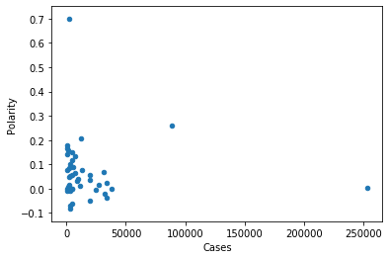

This initial visualization led us to remove New York, California, and Kansas from our following analysis as all three are outliers in the data, whether in number of cases (in the case of New York and California) or polarity (Kansas). We then evaluated the data by means of ordinary least squares regression, pictured in Figure 5.

**Figure 5. OLS Regression on Congress Tweet Polarity by COVID-19 Cases**

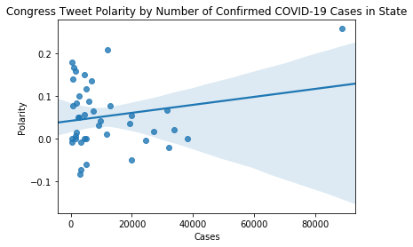

This regression provided us with a slope of 0.000001, an intercept of 0.042229, a p-value of 0.214362, and an r-squared value of 0.039249. Therefore, the number of confirmed COVID-19 cases accounts for 3.9% of the variation in the polarity of lawmakers’ Tweets. Further, and more relevant to our analysis, we were unable to reject our null hypothesis of independence between number of cases and polarity.

In summary, we were unable to demonstrate a statistically significant relationship between members of Congress’ Tweet polarity and either the number of cases in each state or political party.

* 1. **Limitations and Areas of Further Research**

In addition to the limitations mentioned in Section II, there are a number of additional factors which may have affected the reliability of our results here. First of all, our measure of polarity is based on values provided by TextBlob. After testing the TextBlob polarity property on a number of sample Tweets about China, the polarity values returned did not match up very well with our own subjective estimates of positivity or negativity. If we cannot trust that the polarity values used truly reflect the sentiment of the Tweets analyzed, then any further analysis will provide inaccurate results. We are also limited by a small sample size. In each of our analyses, we are hampered by a relatively low number of Tweets, members of Congress, and states to use. This means that our observed values must be quite extreme to meet any level of statistical significance.

In future analysis, the first priority would be to ensure the reliability of the sentiment analysis. Next, it would be illuminating to track changes in polarity over time. Our analysis considered Tweets over a four-month period without separating them based on when during that time the Tweets were posted. However, if, as some reports have suggested, Republicans changed their strategy to highlight China’s culpability only in March or April, then it would be revealing to see whether the level of polarity has changed over the course of 2020. It could also be interesting to check if the polarity of President Trump’s Tweets matches that of his party as a whole.

1. **Frequency of China Tweets Before and After the 17 April G.O.P. Memo**

* 1. **Background**

On 18 April 2020, the *New York Times* reported that the G.O.P. is pursuing a strategy in advance of the 2020 presidential election that aims to place the blame on China for the ongoing health crisis, thereby diverting attention away from the Trump administration’s own COVID-19 response.[16] A memo, circulated by the National Republican Senatorial Committee just one day earlier, provides explicit instructions that campaigns should be emphasizing key points such as: “China is an adversary,” the “Chinese Communist Party caused this pandemic,” and “President Trump is right to call this the Chinese virus.”[17] From our previous analysis, we already know that more Republicans than Democrats in Congress had been Tweeting about China since 1 January 2020. We decided to further build on this finding to determine whether or not members of Congress, particularly Republicans, were Tweeting more about China after the G.O.P. guidance was issued in mid-April than they had been previously.

* 1. **Methodology**

To do so, we scraped the Twitter profiles of both Democrats and Republicans using Tweepy for the period before the G.O.P. guidance was issued (“Before”) and after (“After”). Next, we used Textblob to sort and count the number of Tweets that contained key words like “Beijing,” “China,” “Chinese,” and “Wuhan” for each period. All data was organized into Pandas Dataframes. Finally, we used geospatial data from ArcGIS to create visualizations with Geopandas as well as the red and blue color palettes from Seaborn (see Figure 6). Note that both Alaska and Hawaii were removed from the visualizations for aesthetic purposes, though there was 1 Tweet from a Democrat in Hawaii and 1 Tweet from a Republican in Alaska during the 16-30 April 2020 time period (and none for either party in either state during the 1-15 April 2020 time period).

We hypothesized that in the period after the G.O.P. guidance was issued, there would be an increase in the number of Tweets mentioning China by Republicans in Congress relative to the period before the guidance was issued. However, it was not clear whether Democrats in Congress would follow suit, either as a reflection of general antagonism towards China in light of the ongoing crisis or perhaps as a way to counter the G.O.P.’s new strategy.

**Figure 6. States Where Congresspersons Are Tweeting About China**

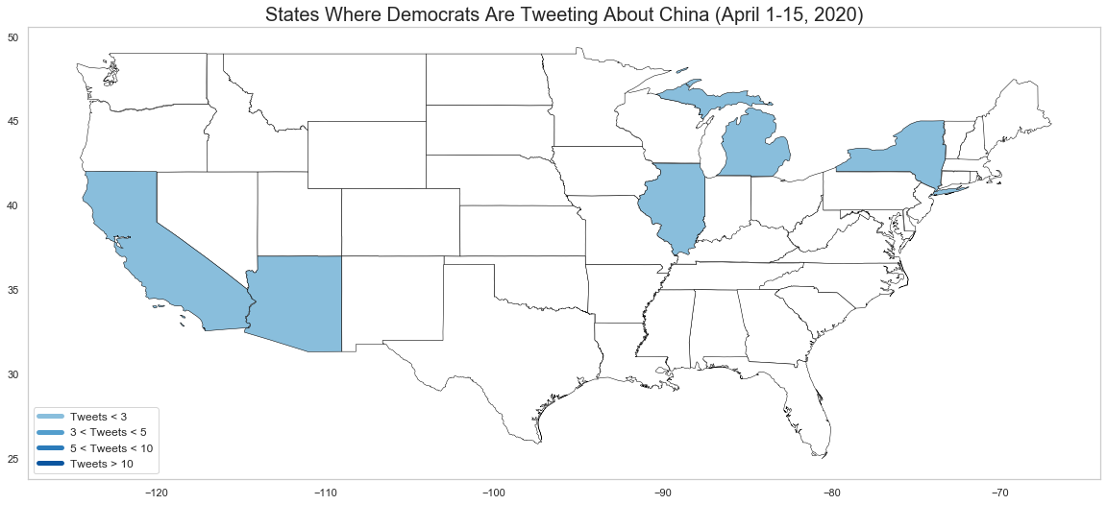 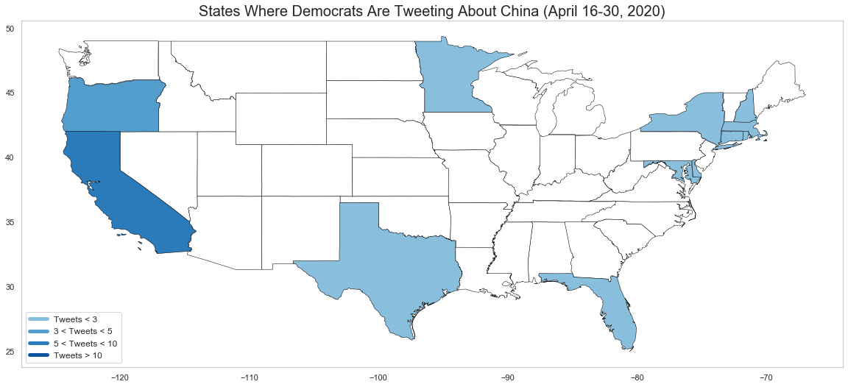

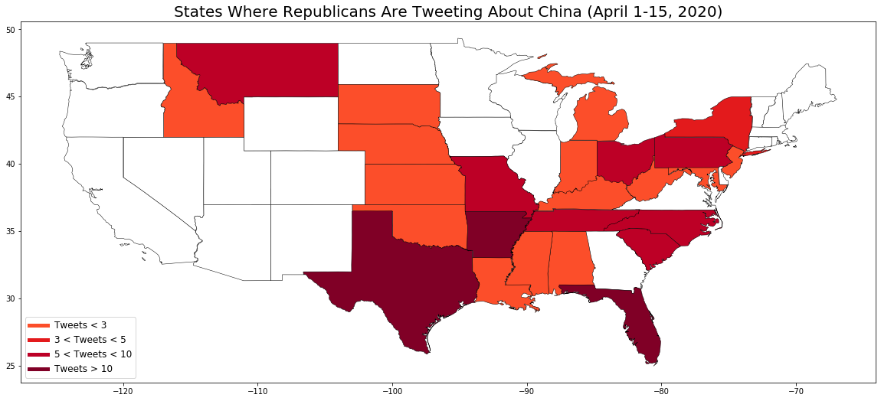 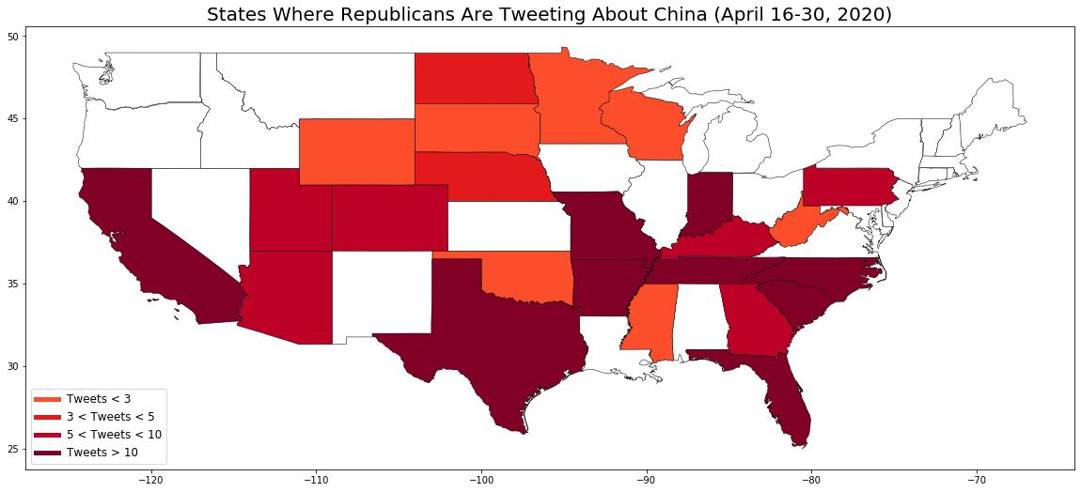

* 1. **Analysis**

As reflected in Figure 6, the number of Tweets about China (“China Tweets”) increased for both parties from the “Before” to “After” period. This is true both on average and in absolute terms: in the “Before” period, we observed 6 Democrats who posted a total of 6 China Tweets (on average, 1 China Tweet per Congressperson) and 61 Republicans who posted a total of 151 China Tweets (on average, 2.475 China Tweets per Congressperson). In comparison, we observed 30 Democrats posting a total of 45 China Tweets (on average, 1.5 China Tweets per Congressperson) versus 94 Republicans posting a total of 364 China Tweets (on average, 3.87 China Tweets per Congressperson) in the “After” period.

It is interesting to note that there are more Democrats than Republicans in Congress, as reflected in our dataset for the periods in question. Even so, a majority of Congresspeople Tweeting about China in both the “Before” and “After” periods were Republicans.Senator Marsha Blackburn, a Republican from Tennassee, posted the most China Tweets for a single Congressperson in the “After” period, with a total of 28. The Democrat with the highest number of China Tweets during the same period was Congressman Bill Pascrell from New Jersey, with a total of 4. Both maximum values still exceeded their counterparts in the “Before” period, with Republican Senator Tom Cotton of Arkansas having Tweeted about China 16 times and no Democrat having posted more than once each.

California, Florida, Minnesota, and Texas are interesting cases because we observed an increase in China Tweets for both parties in all of these states over the relevant time periods. For example, the number of China Tweets posted by Democrats in California increased from 1 to 8, while that of Republicans increased from 0 to 13. Our analysis therefore narrows down specific cases that may warrant further study--indeed, future researchers may wish to perform a deeper dive on the specific China Tweets and/or the Congresspersons who posted them (as well as their constituencies) to understand the various factors that might be driving this increase, whether it be the 17 April 2020 memo or something else.

In all, the evidence supports our hypothesis that Republican members of Congress posted more China Tweets after the G.O.P. guidance was issued in mid-April. We also learned that Democrats in Congress were Tweeting more about China, too. In absolute and relative terms, however, we found that Republicans posted more China Tweets than did Democrats in both the “Before” and “After” periods.

* 1. **Limitations and Areas of Further Research**

Despite these findings, we cannot infer any causal relationship between the publishing of the 17 April 2020 memo and the increase in China Tweets by members of both parties. Further statistical tests would be necessary in order to do so, but this was outside the scope of our analysis. Additionally, this analysis only takes into account *frequency* of Tweets, but does not tell us anything about their *polarity*. Without looking at the Tweets themselves, or running them through a sentiment analysis tool, it is possible that some of the assumptions we have made are incorrect. In other words, an increase in mentions of China does not necessarily indicate that these Tweets represent negative attitudes towards the country.

t also may be possible that some Tweets including the key words “China,” “Chinese,” “Beijing,” and/or “Wuhan” may not have had anything to do with attitudes towards China, either positive, negative, or neutral. For example, Congresswoman Zoe Lofgren, a Democrat from California, reTweeted the following post from the CDC on 5 April 2020: “Need #COVID19 information in a different language? Check out CDC’s COVID-19 web pages in Spanish, simplified Chinese, Vietnamese, and Korean: cdc.gov/coronavirus.” Although this Tweet increased the total number for Democrats in the “Before” time period, it does not reflect a substantive comment on the Chinese state itself.

1. **Conclusion**

We have investigated the change in attitudes towards China amongst lawmakers in the United States since the Chinese government first reported COVID-19 to the W.H.O. on 31 December 2019. Our findings demonstrate that, despite the current composition of the U.S. Congress, a majority of those Tweeting about China since 1 January 2020 have been Republicans. For the narrower period between April 1, 2019 and April 30, 2019, we observed a greater increase in the number of Republicans Tweeting about China than Democrats, both in absolute and relative terms, which appears to support our hypothesis that the G.O.P. strategy released on April 17, 2019 has resulted in a shifting of blame towards China for the present crisis. Limitations of this study, however, prevent us from drawing conclusions regarding any causal relationship between the severity of the crisis in each state and U.S. policy-makers’ attitudes towards China.

Future research and analysis could build on the findings of this report, using more reliable packages for sentiment analysis and conducting more robust statistical tests to develop a clearer understanding of how the crisis has shaped and/or will continue to shape U.S. attitudes towards China. Such attitudes are likely to have broader consequences for U.S.-China relations going forward. Indeed, the Chinese government has responded harshly to recent accusations by U.S. Secretary of State Mike Pompeo that the coronavirus can be traced to a lab in Wuhan, stating: “The huge drama of blame-shifting in the United States has already been heavily spoiled, and continuing the drama is meaningless.”[18] How U.S. politicians continue to react to allegations of Beijing’s role in the current pandemic may contribute to escalating tensions in an already fraught relationship with China, and therefore merits further study.

1. **Endnotes**

   Derrick Bryson Taylor, “How the Coronavirus Pandemic Unfolded: A Timeline,” *New York Times*, May 5, 2020, <https://www.nytimes.com/article/coronavirus-timeline.html>.
2. “Rolling Updates on Coronavirus Disease (COVID-19), *World Health Organization*, May 4, 2020, <https://www.who.int/emergencies/diseases/novel-coronavirus-2019/events-as-they-happen>.
3. Andrew Joseph and Megan Thielking, “WHO praises China’s Response to Coronavirus, will Reconvene Expert Committee to Assess Global Threat,” *STAT News*, January 29, 2020, <https://www.statnews.com/2020/01/29/who-reconvene-expert-committee-coronavirus/>.
4. Bethania Palma, “Did Trump Praise China for Its ‘Transparency’ on COVID-19?” *Snopes*, April 16, 2020, <https://www.snopes.com/fact-check/trump-china-transparency/>.
5. Caitlin Oprysko, “Trump on a Nationwide Lockdown: ‘I Don’t Think We’ll Ever Find that Necessary,” *Politico*, March 20, 2020, <https://www.politico.com/news/2020/03/20/trump-coronavirus-nationwide-lockdown-139330>.
6. “The President’s Coronavirus Guidelines for America,” *The White House*, [https://www.whitehouse.gov/ wp-content/uploads/2020/03/03.16.20_coronavirus-guidance_8.5x11_315PM.pdf](https://www.whitehouse.gov/wp-content/uploads/2020/03/03.16.20_coronavirus-guidance_8.5x11_315PM.pdf).
7. Romesh Vaitilingam, “How Does Economic Policy Interact with Public Health Measures for COVID-19?” *CBR*, March 30, 2020, [https://review.chicagobooth.edu/economics/2020/article/how-does-economic- policy-interact-public-health-measures-covid-19](https://review.chicagobooth.edu/economics/2020/article/how-does-economic-policy-interact-public-health-measures-covid-19).
8. Tucker Reals, Sarah Lynch Baldwin, Victoria Albert, and Justin Carissimo, “Coronavirus Updates from April 30, 2020,” *CBS News*, May 1, 2020, [https://www.cbsnews.com/live-updates/coronavirus-updates- 2020-04-30/](https://www.cbsnews.com/live-updates/coronavirus-updates-%202020-04-30/).
9. Graham Allison, “The Thucydides Trap: Are the U.S. and China Headed for War?” *The Atlantic*, September 24, 2015, <https://www.theatlantic.com/international/archive/2015/09/united-states-china-war-thucydides-trap/406756/>.
10. “National Security Strategy 2015,” *National Security Strategy Archive*, February 6, 2015, <http://nssarchive.us/national-security-strategy-2015/>.
11. “National Security Strategy 2017,” *The White House*, December 2017, <https://www.whitehouse.gov/wp-content/uploads/2017/12/NSS-Final-12-18-2017-0905.pdf>.
12. Bethany Allen-Ebrahimian, “D.C.’s Bipartisan China Consensus may be Unraveling,” *Axios*, April 1, 2020, <https://www.axios.com/washington-bipartisan-coronavirus-china-consensus-unraveling-98170aa4-5bcc-42cf-a918-44431cf04f69.html>.
13. “Membership of the 116th Congress: A Profile,” *Congressional Research Service*, March 31, 2020, <https://fas.org/sgp/crs/misc/R45583.pdf>.
14. Adam Isacson, “Gigantic 116th Congress Spreadsheet,” <https://adamisacson.com/116th-congress-spreadsheet/>.
15. Allen-Ebrahimian, “D.C.’s Bipartisan China Consensus may be Unraveling.”
16. Jonathan Martin and Maggie Haberman, “A Key G.O.P. Strategy: Blame China. But Trump Goes Off Message,” *New York Times*, April 18, 2020, <https://www.nytimes.com/2020/04/18/us/politics/trump-china-virus.html>.
17. Alex Isenstadt, “GOP Memo Urges Anti-China Assault Over Coronavirus,” *Politico*, April 24, 2020, <https://www.politico.com/news/2020/04/24/gop-memo-anti-china-coronavirus-207244>.
18. Christina Zhao, “China Criticizes Pompeo Over Coronavirus Wuhan Lab Allegation, Claims Leaked GOP Memo Discredits Trump Theory,” *Newsweek*, May 6, 2020, <https://www.newsweek.com/china-criticizes-pompeo-over-coronavirus-wuhan-lab-allegation-claims-leaked-gop-memo-discredits-1502426>.